**Guide to building games with HTML/TWINE**

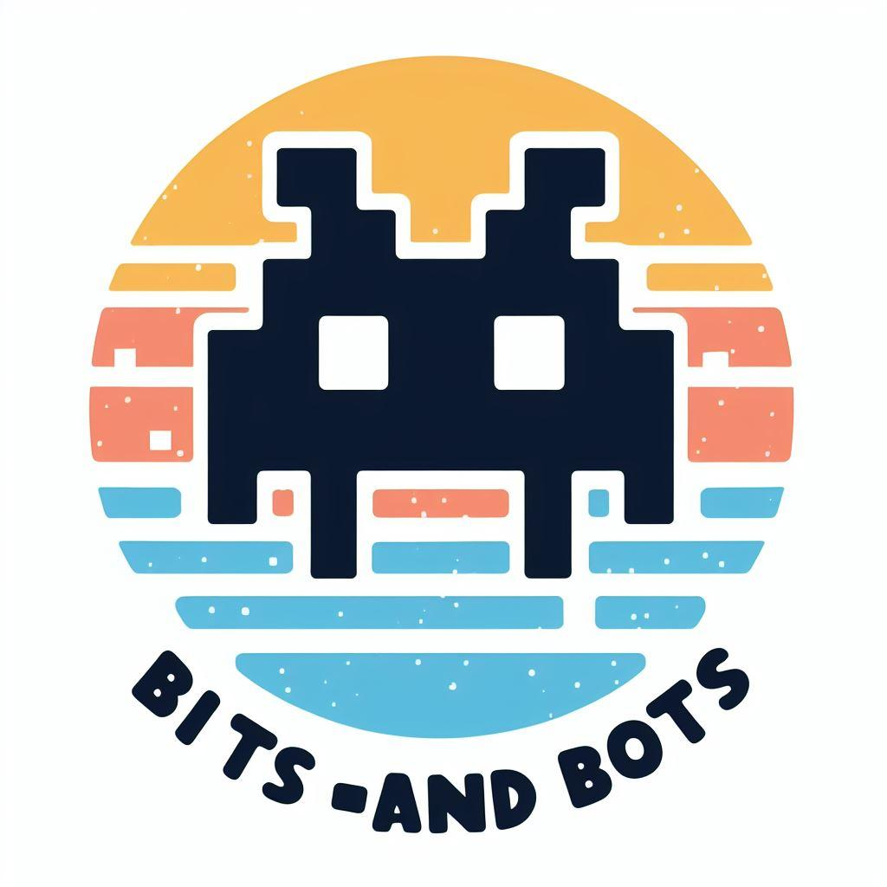With the Bits -and Bots study group

Table of content

Introduction

1. Setup

2. Twine formats

3. Creating a story with Harlowe

4. Exercises

4.1. Working on your first story

Bibliography

Further reading

# Introduction

# Setup

To learn HTML, we are using Twine in this study group. Twine is an open-source tool for telling interactive, nonlinear stories. You can work in HTML, but can also branch out later with CSS and JavaScript if you feel ready. After finishing a story, you can export it as an HTML to share it with other people.

Examples of notable games that were created with Twine:

* Rat Chaos

This game is about a spaceship captain choosing between going about their daily routine or “unleashing rat chaos”. Fun fact: While learning the software Twine, the author created this game in a couple hours on a single day (July 18th, 2012).

Link: <https://debacle.us/ratchaos/>

* You Are Jeff Bezos

You start the game by waking up as Jeff Bezos. To get back to your own body, you eed to spend all of Jeff Bezos’ money. Then the game provides you with various choices that you can spend the money on. These choices evoke reactions.

Link: <https://direkris.itch.io/you-are-jeff-bezos>

So let’s start setting up your first Twine story!

There are two options to set up for your first Twine story: the **desktop app** and the **browser-version**. The browser-version release uses your selected web-browser's Local Storage to store all the passages of your story, and by default the web-browser's Local Storage area is limited in size to between 5-10MBs (depends on the brand & version) which means you are limited if you want to embed media files within the passages of your story. The Local Storage are can also be effected by the "Empty Cache" (or similar concepts) feature of the web-browser ( this depends on brand & settings) so it is recommend to regularly use the Twine 2 Archive option to backup all your projects in one go, or to use the Publish to File option to create locally stored HTML files for each of your projects.

The **desktop app** release stores each Story Project as a local file in a automatically pre-determined location/folder on your local machine, this location should not be used by you as a destination for the Story HTML file you create using the Publish to File option or you could end up overwriting (and losing) your projects. Because this release uses local files for storage then the limits on embedding a media file in a Passage is removed.

You can find both options on the home page of Twine (Twinery): <http://twinery.org/>. Whichever option you choose, you can create a new story. After creating a new story, your screen should look like this:

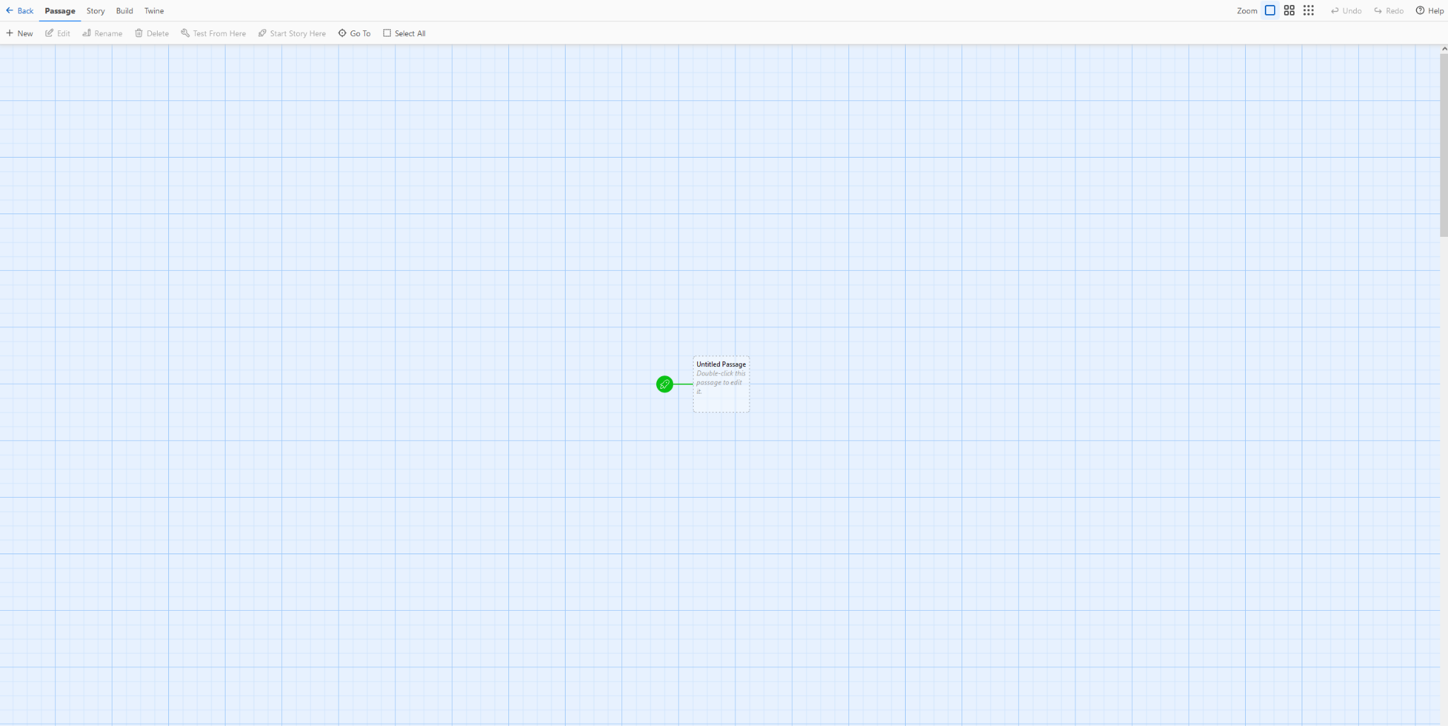

Note that for the images in this guide, the browser-version was used.

So before we really start working on building your story, let's get into the available story formats that Twine offers.

# Twine formats

There are multiple story formats that come with Twine 2, and they serve different purposes.

* Harlowe is the default story format, and is focused on making it easy to add basic interaction to your stories in a readable, concise way.
* Snowman is designed to be used by people who are familiar with writing JavaScript and CSS, two broadly-used Web technologies, and makes it easy to build a heavily-customised reading experience.
* SugarCube comes from the world of Twine 1. It gives readers the ability to save their progress into separate slots and provides a large collection of functionality for authors.
* Chapbook the first of a "second-generation" story formats, it is designed for newer users with advanced functionality built into its inserts and modifiers.

# Creating a story with Harlowe

Harlowe is the default story format while resting a Twine, so you don’t have to do anything to activate this.

# Exercises

## Working on your first story

Create a story (it does not have to be huge) where you gamify an aspect of your work. It could be about a subject you know a lot about, workflows you have or decisions that you need to make every day. Make sure you use the basics discussed in the previous chapter. If you would like to add some extra functionalities, check out what more you can add.

Potential guides to use:

* <https://twine2.neocities.org/>
  1. ..

## 

## 

# Bibliography

# Further reading